TCS3351 Cryptography and Data Security
Tutorial 5 Questions
Modern Symmetric Ciphers-II (Advanced Encryption Standard (AES))

- Answer the following questions with respect to Advanced Encryption Standard (AES).

  - List the block size, key size, number of rounds, number of round keys, and number of transformations for the three AES versions.
  - Define a state in AES. How many states are there in each version of AES?
  - If a and b are two bytes, show that
SubBytes (a⊕b) ≠ SubBytes (a) ⊕ SubBytes (b)
Use a = (35)₁₆ and b = (46)₁₆ as an example.

Answer:
- Block size: 128-bit

AES | Key Size | No. of Rounds | No. of Round Keys | No. of Transformation
128 | 128 | 10 | 11 | 40
192 | 192 | 12 | 13 | 48
256 | 256 | 14 | 15 | 56
; round0 original key is used.
- A state in AES refers to a data block.
- AES–128: 41 states
- AES–192: 49 states
- AES–256: 57 states

- $a={\left(35\right)}_{16}={\left(00110101\right)}_{2}$; $SubBytes\left(a\right)={\left(96\right)}_{16}={\left(10010110\right)}_{2}$
$b={\left(46\right)}_{16}={\left(01000110\right)}_{2}$; $SubBytes\left(b\right)={\left(5A\right)}_{16}={\left(01011010\right)}_{2}$

$a⊕b={\left(01110011\right)}_{2}={\left(73\right)}_{16}$;
$$SubBytes\left(a⊕b\right)=SubBytes \left(73\right)= {\left(8F\right)}_{16}$$

$SubBytes\left(a\right)⊕SubBytes\left(b\right)={\left(11001100\right)}_{2}={\left(CC\right)}_{16}$.

Hence, $SubBytes\left(a⊕b\right)≠SubBytes\left(a\right)⊕SubBytes\left(b\right)$.

- With respect to Advance Encryption Standard, answer the following:
Given the plaintext
(00 01 02 03 04 05 06 07 08 09 0A 0B 0C 0D 0E 0F)_{H}
and the key
(01 01 01 01 01 01 01 01 01 01 01 01 01 01 01 01)_{H}

- Show the original contents of State, displayed as a 4×4 matrix.
- Show the value of State after the initial AddRoundKey.
- Show the value of State after SubBytes.
- Show the value of State after ShiftRows.
- Show the value of State after MixColumns.

Answer:
- The original state
00 | 04 | 08 | 0C
01 | 05 | 09 | 0D
02 | 06 | 0A | 0E
03 | 07 | 0B | 0F

- The output state after initial AddRoundKey:

00 | 04 | 08 | 0C |  | 01 | 01 | 01 | 01 |  | 01 | 05 | 09 | 0D
01 | 05 | 09 | 0D | $$⊕$$ | 01 | 01 | 01 | 01 | $$=$$ | 00 | 04 | 08 | 0C
02 | 06 | 0A | 0E |  | 01 | 01 | 01 | 01 |  | 03 | 07 | 0B | 0F
03 | 07 | 0B | 0F |  | 01 | 01 | 01 | 01 |  | 02 | 06 | 0A | 0E

- The output state after SubBytes:

01 | 05 | 09 | 0D |  | 7C | 6B | 01 | D7
00 | 04 | 08 | 0C | $$→$$ | 63 | F2 | 30 | FE
03 | 07 | 0B | 0F |  | 7B | C5 | 2B | 76
02 | 06 | 0A | 0E |  | 77 | 6F | 67 | AB

- The output state after ShiftRows:
1st row: no shift, 2nd row shift 1 byte left, 3rd row, shift 2 byte left, 4th row : shift 4 byte left.
7C | 6B | 01 | D7
F2 | 30 | FE | 63
2B | 76 | 7B | C5
AB | 77 | 6F | 67

- The output state after MixColumns:

02 | 03 | 01 | 01 |  | 7C | 6B | 01 | D7 |  | 75 | 87 | 0F | B2
01 | 02 | 03 | 01 | $$×$$ | F2 | 30 | FE | 63 | $$=$$ | 55 | E6 | 04 | 22
01 | 01 | 02 | 03 |  | 2B | 76 | 7B | C5 |  | 7E  3E | 2E | B8 | 8C
03 | 01 | 01 | 02 |  | AB | 77 | 6F | 67 |  | 10 | 15 | 58 | 0A

Row 0: 75 87 0F B2
Row 1: 55 E6 04 22
Row 2: 3E 2E B8 8C
Row 3: 10 15 58 0A

(02 * 7c) XOR (03 * F2) xor (01 * 2B) xor (01 * AB)
02 = 0000 0010 = x
7c = 0111 1100 = $x^{6}+ x^{5}+x^{4}+x^{3}+x^{2}$
(02 * 7c) = $\left(x^{6}+ x^{5}+x^{4}+x^{3}+x^{2}\right)x= x^{7}+ x^{6}+x^{5}+x^{4}+x^{3}=1111 1000$. (F8)

03 = 0000 0011 = x + 1
F2 = 1111 0010 = $x^{7}+ x^{6}+x^{5}+x^{4}+x$
(03 * F2) = $(x^{7}+ x^{6}+x^{5}+x^{4}+x$) ( x + 1)
= ${(x^{8}+x}^{7}+ x^{6}+x^{5}+x^{2}$) +$(x^{7}+ x^{6}+x^{5}+x^{4}+x$) ; + is xor
= $x^{8}$+ $x^{4}{+x}^{2}+x$; Note that : $x^{8}= x^{4}+x^{3}+x+1$
= $x^{4}+x^{3}+x+1$ + $x^{4}+x^{2}+ x$
= $x^{3}+x^{2}+1$ = 0000 1101

2B = 0010 1011
AB = 1010 1011

02xFC | 1111 | 1000
03 x f2 | 0000 | 1101
2B | 0010 | 1011
AB | 1010 | 1011
XOR | 0111 | 0101
 | 7 | 5

Inverse Mix Column.

0e | 0b | 0d | 09 |  | 75 | 47  87 | 0F | B2  A9 |  | 7C | 6B | 01 | D7
 |  |  |  | $$×$$ | 55 | E6  FD | 04  1F | 22  39 | = | F2 | 30 | FE | 63
 |  |  |  |  | 7E  3E | 2E | B8 | 8C  97 |  | 2B | 76 | 7B | C5
 |  |  |  |  | 10 | 15  oe | 58  43 | 0A  11 |  | AB | 77 | 6F | 67

0e = 0000 1110 = $x^{3}+x^{2}+x$
75 = 0111 0101 = $x^{6}+x^{5}+x^{4}+x^{2} +1$
(0e * 75) = ${(x}^{3}+x^{2}+x) (x^{6}+x^{5}+x^{4}{+ x}^{2}+1)$
= $x^{3}\left(x^{6}+x^{5}+x^{4}{+ x}^{2}+1\right)+x^{2}\left(x^{6}+x^{5}+x^{4}{+ x}^{2}+1\right)+x(x^{6}+x^{5}+x^{4}{+ x}^{2}+1)$
= $x\left(x^{8}+x^{7}+x^{6}{+ x}^{4}{+ x}^{2}\right)+x\left(x^{7}+x^{6}+x^{5}{+ x}^{3}+x\right)+x(x^{6}+x^{5}+x^{4}{+ x}^{2}+1)$
= $x\left(x^{8}\right)+x$(${ x}^{6}{+ x}^{3}+x+1)$
= $x\left(x^{4}{+ x}^{3}+x+1\right)+x$(${ x}^{6}{+ x}^{3}+x+1)$
=${ x}^{5}+{ x}^{4}+{ x}^{2}+x+ { x}^{7}{+ x}^{4}+{ x}^{2}+x$
= ${ x}^{7}+{ x}^{5}$
= 1010 0000 = A0

(0e * 75) = A0 = 1010 0000
(0b * 55) = 61 = 0110 0001
(0d * 3e) = 2D = 0010 1101
(09 *10) = 90 = 1001 0000
0111 1100 = 7C

There is a mistake in the previous answer (matrix), that why the inverse Mix-Column calculation cannot be done.

Note:

- SubByte Transformation Table
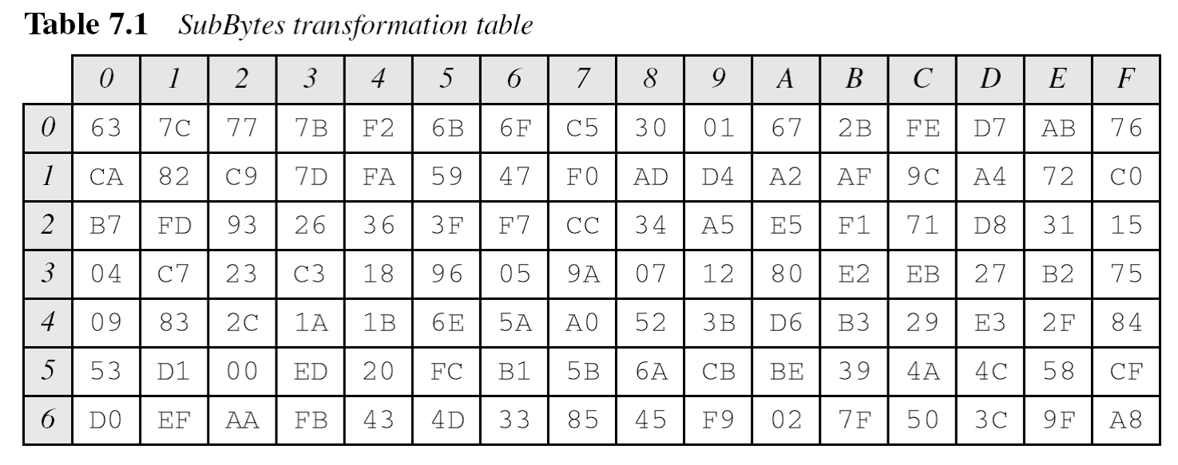
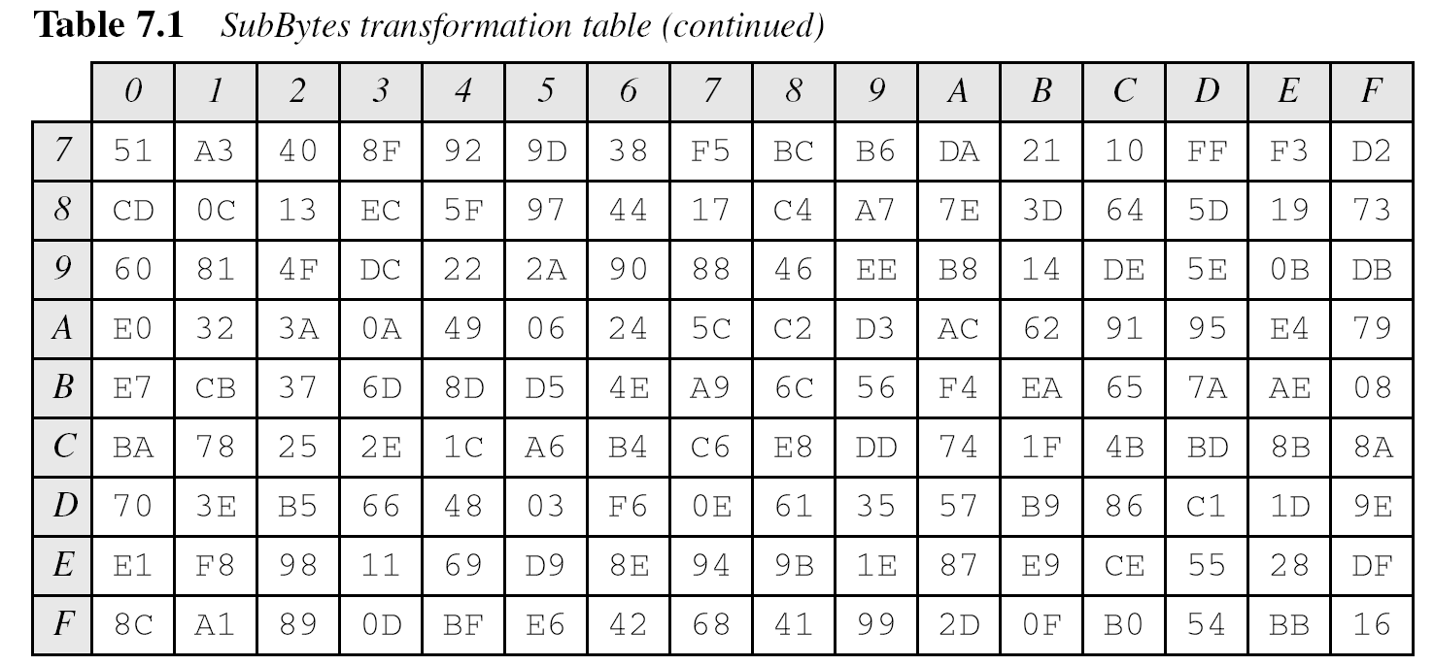

(ii) Constant matrices used by MixColumns and InvMixColumns

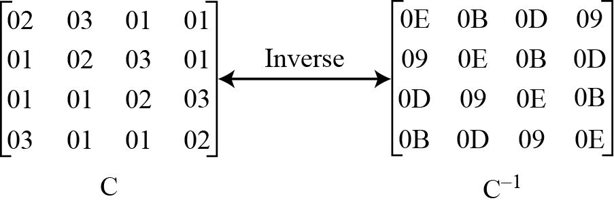

- With reference to Advanced Encryption Standard (AES-128) key expansion algorithm, identify the first 3 subround keys. Given Key:

(0F 15 71 C9 47 D9 E8 59 0C B7 AD D6 AF 7F 67 98)_{H}

Answer:
$w_{o}=\left(0F 15 71 C9\right)$; $w_{1}=\left(47 D9 E8 59\right)$;
$w_{2}=\left(0C B7 AD D6\right)$; $w_{3}=\left(AF 7F 67 98\right)$

Round 1:
RotWord: Circular byte shift, $w_{3}= \left(7F 67 98 AF\right)$
SubWord: ByteSubstitution $=\left(D2 85 46 79\right)$
Adding Round Constant: $\left(D2 85 46 79\right)⊕\left(01 00 00 00\right)=\left(D3 85 46 79\right)$
Hence, $t_{4}=\left(D3 85 46 79\right)$

$w_{4}=w_{0}⊕t_{4}=\left(0F 15 71 C9\right)⊕\left(D3 85 46 79\right)=\left(DC 90 37 B0\right)$
$w_{5}=w_{4}⊕w_{1}=\left(DC 90 37 B0\right)⊕\left(47 D9 E8 59 \right)=\left(9B 49 DF E9\right)$
$w_{6}=w_{5}⊕w_{2}=\left(9B 49 DF E9\right)⊕\left(0C B7 AD D6\right)=\left(97 FE 72 3F\right)$
$w_{7}=w_{6}⊕w_{3}=\left(97 FE 72 3F\right)⊕\left(AF 7F 67 98\right)=\left(38 81 15 A7\right)$

First round key:
$$\left(DC 90 37 B0 9B 49 DF E9 97 FE 72 3F 38 81 15 A7\right)$$

Round 2:
RotWord: Circular byte shift, $w_{7}≔\left(81 15 A7 38\right)$
SubWord: ByteSubstitution: $\left(0C 59 5C 07\right)$
Adding Round Constant: $\left(0C 59 5C 07\right)⊕\left(02 00 00 00\right)=\left(0E 59 5C 07\right)$
Hence, $t_{8}=\left(0E 59 5C 07\right)$

$w_{8}=w_{4}⊕t_{8}=\left(DC 90 37 B0\right)⊕\left(0E 59 5C 07\right)=\left(D2 C9 6B B7\right)$
$w_{9}=w_{8}⊕w_{5}=\left(D2 C9 6B B7\right)⊕\left(9B 49 DF E9\right) =\left(49 80 B4 5E\right)$
$w_{10}=w_{9}⊕w_{6}=\left(49 80 B4 5E\right)⊕\left(97 FE 72 3F\right)=\left(DE 7E C6 61\right)$
$w_{11}=w_{10}⊕w_{7}=\left(DE 7E C6 61\right) ⊕\left(38 81 15 A7\right)=\left(E6 FF D3 C6\right)$

Second round key:
$$\left(D2 C9 6B B7 49 80 B4 5E DE 7E C6 61 E6 FF D3 C6\right)$$

Round 3:
RotWord: Circular byte shift, $w_{11}=\left(FF D3 C6 E6\right)$
SubWord: ByteSubstitution $=\left(16 66 B4 8E\right)$
Adding Round Constant: $\left(16 66 B4 8E\right)⊕\left(04 00 00 00\right)=\left(12 66 B4 8E\right)$
Hence, $t_{12}=\left(12 66 B4 8E\right)$

$w_{12}=w_{8}⊕t_{12}=\left(D2 C9 6B B7\right)⊕\left(12 66 B4 8E\right)=\left(C0 AF DF 39\right)$
$w_{13}=w_{12}⊕w_{9}=\left(C0 AF DF 39\right)⊕\left(49 80 B4 5E\right)=\left(89 2F 6B 67\right)$
$w_{14}=w_{13}⊕w_{10}=\left(89 2F 6B 67\right)⊕\left(DE 7E C6 61\right)=\left(57 51 15 06\right)$
$w_{15}=w_{14}⊕w_{11}=\left(57 51 15 06\right)⊕\left(E6 FF D3 C6\right)=\left(B1 AE C6 60\right)$

Third round key:
$$\left(C0 AF DF 39 89 2F 6B 67 57 51 15 06 B1 AE C6 60\right)$$

References:

1. Behrouz A. Forouzan, "Cryptography and Network Security", First Edition, McGraw-Hill, 2008

2. William Stallings, “Cryptography and Network Security – Principles and Practice”,
Seventh Edition, Prentice Hall, 2016.

02 | 03 | 01 | 01 |  | E1 | 01 | 01 | 01 |  | Y | X | X | X
01 | 02 | 03 | 01 | $$×$$ | F2 | 01 | 01 | 01 | $$=$$ | X | X | X | X
01 | 01 | 02 | 03 |  | 03 | 01 | 01 | 01 |  | X | X | X | X
03 | 01 | 01 | 02 |  | 04 | 01 | 01 | 01 |  | X | X | X | X

